January 19, 2022

Dear Ms. Donahue,

Congratulations! I am pleased to notify you that the Town of Uxbridge has been awarded a grant under the Air Sensor Grant Program. I want to thank you for your commitment to increasing awareness of air pollution for the benefit of your community and the environment.

Enclosed you will find further instructions from the Department of Environmental Protection on next steps. Please feel free to contact Joanne Morin at joanne.o.morin@mass.gov if you have any questions.

Governor Charles D. Baker Lt. Governor Karyn E. Polito

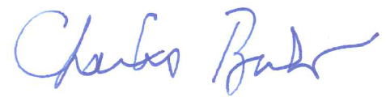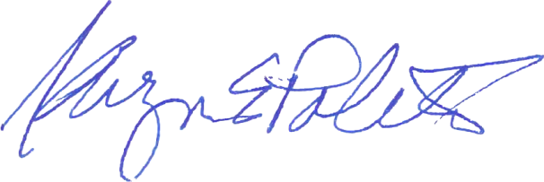

Uxbridge Board of Health is excited to announce that Uxbridge has received five PurpleAir Sensors thru the MassDEP Air Sensor Grant Program. These sensors are installed at Uxbridge High, Whitin Intermediate, Taft Elementary, Uxbridge Library and Town Hall. These sensors measure fine particulate matter (PM 2.5) in the air. PM 2.5 is a mixture of solid particles and liquid droplets found in the air and can be made up of hundreds of different chemicals. These particles are so small that they can be inhaled deep into the lungs and may even enter a person’s bloodstream. These will be used to help monitor Uxbridge’s air quality.
Residents may view live the PurpleAir map at: Real-Time Air Quality Map | PurpleAir

