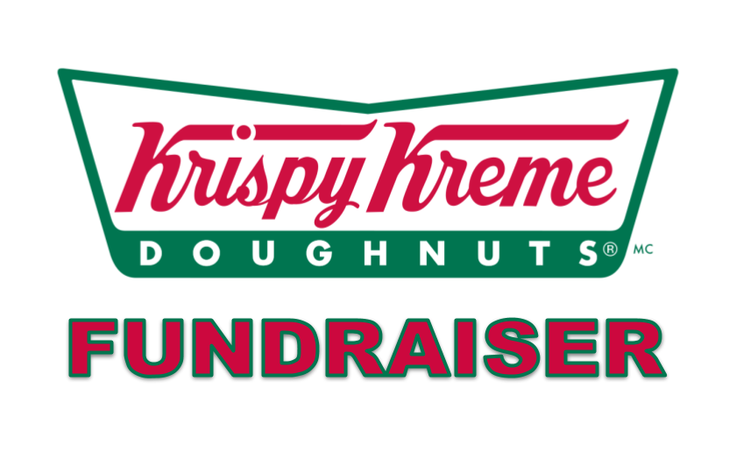

**Krispy Kreme Doughnut Fundraiser** – Help us raise Dough for our Senior Activities! Krispy Kreme Original Glazed® sell at a price of $10.00 per dozen. ***We challenge you to sell, as well, and top seller will receive a $20.00 Hannaford Gift Card*!** *Ps. These doughnuts freeze well* 😊

**Pre-Order yours now by calling 508-278-8622. Pickup will be on Friday, April 30th from 10 am – 5:00 pm at the Uxbridge Senior Center, 36 S. Main Street, Uxbridge. Consider buying a dozen for a senior!**

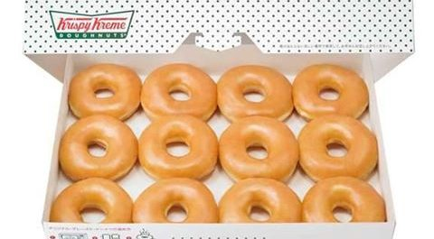

**KRISPY KREME ORDER FORM**

|  |  |  |
| --- | --- | --- |
| **CUSTOMER NAME/ADDRESS/PHONE** | **DOZEN PURCHASED** | **AMOUNT COLLECTED** |
|  |  |  |
|  |  |  |
|  |  |  |
|  |  |  |
|  |  |  |
|  |  |  |
|  |  |  |

**Seller Name/Address/Phone: _____________________________________________________________________________________**

**Donuts are $10 dozen/Please send order form and money collected to the Uxbridge Senior Center**

**by Friday, April 23rd.**