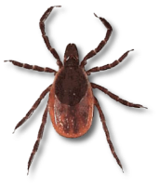 Ticks
Keeping Yourself Safe

As we approach the spring and summer, ticks are going to become more common and active. Follow the tips below to protect yourself and others against tickborne illnesses!

- When going hiking or into nature, keep by main trails. Avoid coming into contact with bushes, woody areas, or tall grasses
- Even when it’s hot, make sure to wear long-sleeved, light-colored shirts and long pants. Remember to tuck your pants into your socks
- Use EPA approved repellents:
  - DEET can be applied directly to the skin, but avoid applying to fresh cuts, or near face/eyes. Put on hands and then apply to face manually
  - Permethrin should be used on clothing or materials, never to skin. You can also purchase permethrin-treated clothing if you work in an area where you are consistently exposed to ticks
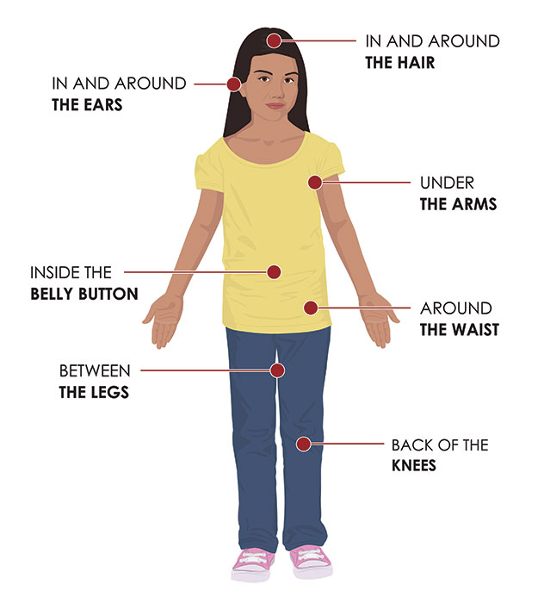
- After coming in from the outdoors, make sure to check clothes, pets, and backpacks. Ticks can hitch a ride on these and migrate to people
- Perform a thorough tick check every day after coming in from the outdoors. Make sure to pay special attention to:
  - Under the arms
  - In or around the ears
  - Back of the knees
  - In and around hair
  - Between the legs/groin
  - Waist
- Remember that ticks can be very small (see tick card on this tip-sheet for reference), so look for any new “freckles” that appear
- Take a cleansing shower within 2 hours of coming in from the outdoors to wash off unattached ticks. This is also an excellent opportunity to perform a tick check!
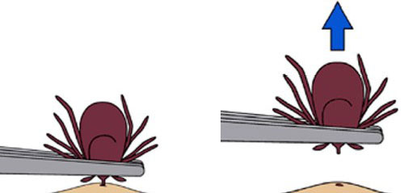
- If you find a tick attached to you, don’t panic! Use a pair of thin-tipped tweezers (or tick-remover device if you have one) to remove the tick. Make sure to grab the tick as close to the skin as possible. Apply steady, even pressure to remove the tick. Don’t yank or twist, as that might break off the mouth parts in the bite. If this happens, use a pair of tweezers to remove them. If you can’t, leave it alone and allow the wound to heal
  - After you remove the tick, place it either in alcohol, a sealed bag, or wrap it firmly in tape, or flush it down the toilet
  - Remember to wash the wound site with soap and water or rubbing alcohol
- The sooner a tick is removed, the less likely you are to become sick. Call your doctor if you develop fever, chills, or muscle aches after removing a tick, or if you notice a rash near the area of the tick-bite
- For more information regarding tick-borne illnesses, such as Lyme Disease, Anaplasmosis, Babesiosis, and others, please see the mass.gov DPH fact sheets at https://www.mass.gov/tick-borne-diseases

