Mattress Recycling
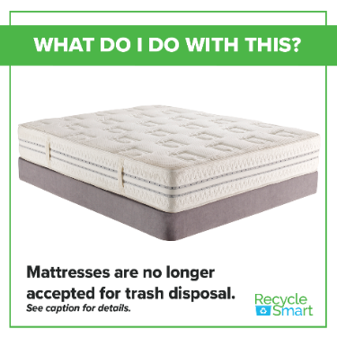

As of November 1, 2022 Mattresses are added to the list of materials banned from disposal or transport for disposal in Massachusetts.

To help you understand these changes and the reasons behind them, the MassDEP has written a newsletter focusing on the new Waste Bans and why they are important. You can read the newsletter in its entirety here:
Waste Bans 101: Less Trash for a Cleaner Massachusetts

OPTIONS FOR DISPOSAL OF MATTRESSES:

Tom Berkowitz Trucking Inc. (fee for disposal)
http://tomberkowitztruckinginc.com/
279 Douglas Road
Whitinsville, MA 01588
(508) 234-2920

Blackstone Valley Regional Recycling Center (fee for disposal)
14 Chestnut St
Blackstone, MA 01504
(508) 876-5129 or (508) 876-5130
Alternate Phone: (508) 883-9169

Green Team Junk Removal (fee for disposal)
59 Central St, Holliston, MA 01746, USA
508-361-0519 http://www.gogreenteamjunk.com

CHARITY (mattress must be stain free with no holes)
Central Mass Housing Alliance (call for information)
774-243-3821 or email dch@cmhaonline.org
Textile Recovery and Recycling
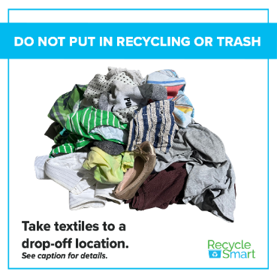

As of November 1, 2022 Textiles will no longer be allowed in the trash.

Textile Recovery
About 230,000 TONS of textiles are disposed of annually in Massachusetts – 95% of which could have been reused, resold, or remade into something new instead. Textiles are anything from clothing (shirts, sweaters, pants) to footwear (sneakers, sandals, cleats) to accessories (bags, belts, hats) to linens (sheets, towels, and more).
The Town of Uxbridge is partnering with Big Brother Big Sister Foundation and CMRK to collect clothing, textiles, housewares and more! These collections divert clothing and housewares out of the landfill. When you donate, you are helping our town and children across the state. You can schedule your free home pickup by calling or texting PICKUP to 508-466-4590 or scheduling online at: https://www.bbbsfoundation.org/
There are many paths your used textiles can take:
- Donated textiles can be given or resold to people who need them here in the US and abroad.
- Textiles in poor condition can become industrial wiping cloths, aka "shop rags".
- Anything that cannot be resold can be remanufactured into insulation used by a variety of industries (e.g., automotive, home furnishings, and carpet padding).
Textiles should never go in your household recycling bin. They also do not belong in the trash, unless they are wet, moldy, or contaminated.
Drop off textiles at designated collection bins or donate them to your favorite charity or thrift store. Visit to Beyond the Bin for more information.

